**How To Load Data In Database Tables**

1. **Using Import Function (PHPMyAdmin)**

* Select your database (for eg: doctoral)
* Select the table (eg: Course)
* Click on ‘Import’ function

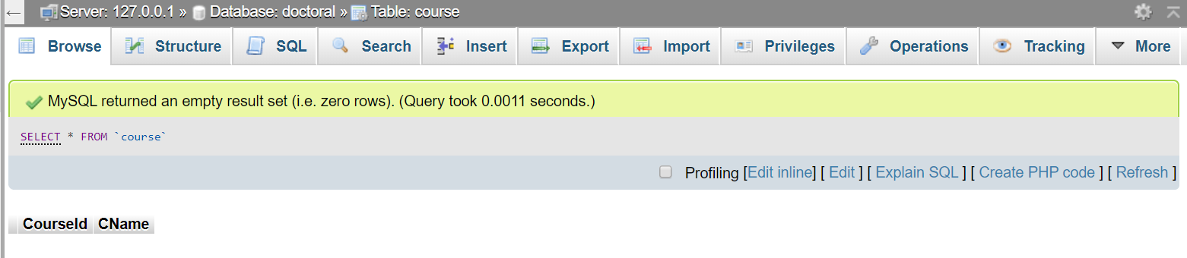

* Choose your file to import from your device (eg:_Course.txt)

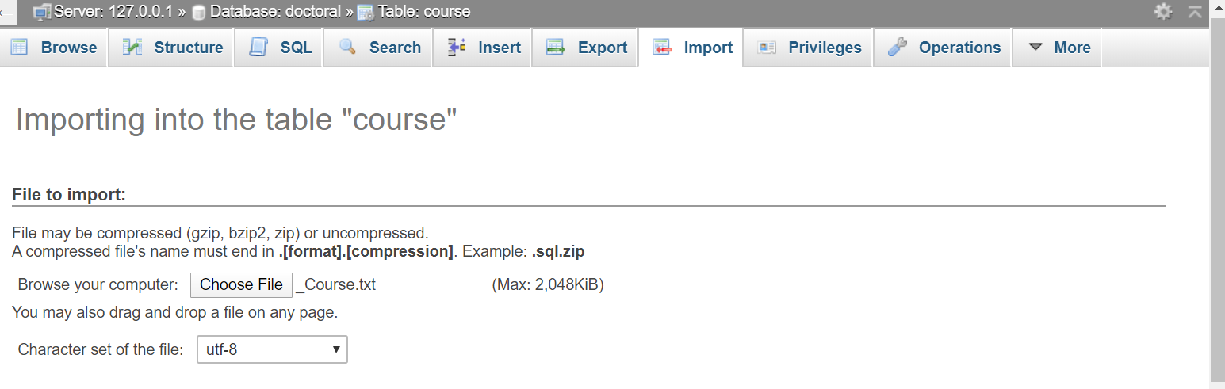

* Change 0 to ‘1’ in Partial Import option if the first record of your data file contains attribute names.

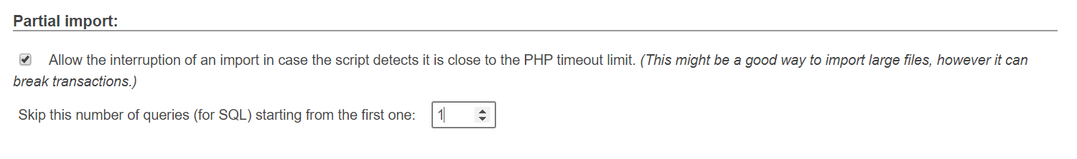

* Select CSV file format, not SQL while importing and do not change any default options.

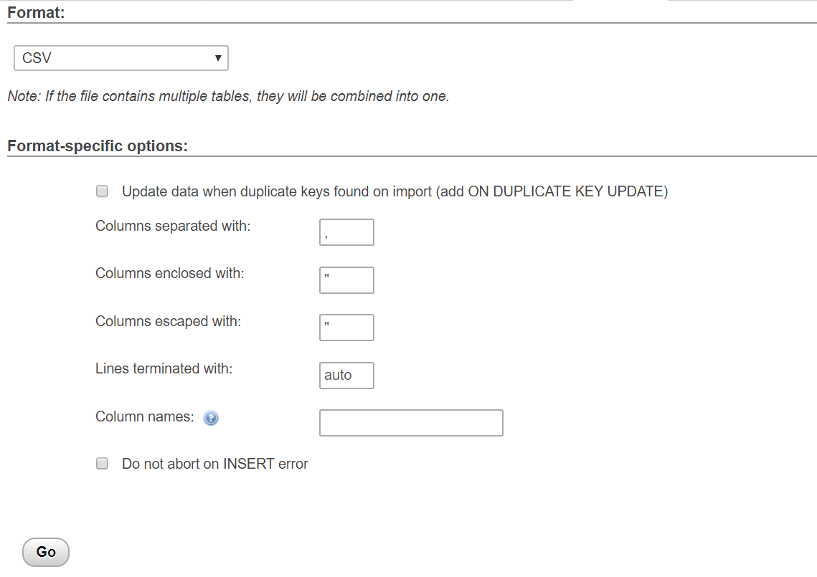

* Click on Go and it should import all records successfully.

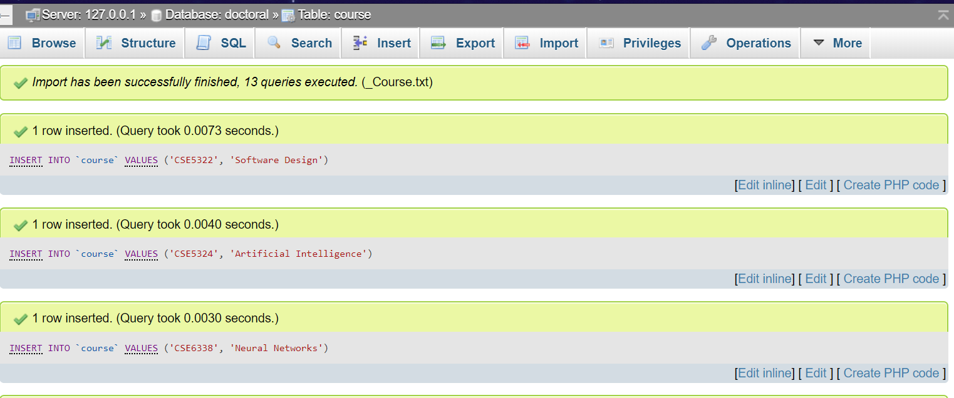

1. **Using Load Data Command.**

Syntax:

LOAD DATA LOCAL INFILE ‘C:/xampp/mysql/data/<database_name>/<file_name>.txt INTO TABLE <table_name> FIELDS TERMINATED BY ‘,’

Example:

LOAD DATA LOCAL INFILE 'C:/xampp/mysql/data/doctoral/_Course.txt' INTO TABLE **Course** FIELDS TERMINATED BY ',' **IGNORE 1 LINES**;

Note: ‘IGNORE 1 LINES’ indicate that the first record is to be skipped since it contains attributes names.